xpedx.com Next Generation
Technical Design Specification – <Order Place>

Author: | Prasanth Kumar M,
Version: | 0.2
Date Created: | 05/04/2010
Last Updated: | 19/05/2010

Document Revision History
Revision | Date | Description | Author
0.1 | 05/04//2010 | Draft | Prasanth Kumar M.
0.2 | 19/05/2010 | Draft | Prasanth Kuamr M.

Document Approval History
Name | Signature | Date | Version Approved/Comments

Reference Documents
Document Name | Description | Owner | Location
SCI_Xpedx Solution Definition Document v1.0 | Solution Definition document | Sterling Commerce

Table of Contents
1. Introduction 4
1.1. Purpose 4
1.2 Nomenclature 4
1.3 Performance Considerations 4
2. Technical Components 4
2.2 Components Overview 4
2.3 Component Design 4
2.3.1 Design for xpedxAsynchLoadItemMaster 4
2.3.2 UI Design 5
2.3.3 UI Validations 5
2.3.4 Input Document 5
2.3.5 Output Document 5
2.3.6 Configuration 5
2.3.1.1. <Insert Sub-Component Name> 6
3. Database Extensions 7
4. Exception and Error Handling 7
5. Security Aspects 7
5.1 Ownership 7
5.2 Encryption 7
5.3 Audit Trail 7
5.4 Other Security Aspects 7
6. Dependencies 7
7. Unit Test Cases 8
7.1 <Insert Component Name> 8

1. Introduction

Purpose
This document is the governing Interface design document for the Order Place Interface. It contains the significant decisions and constructs used in developing the interfaces. The document mentions the steps for order creation(or confirmation) and the subsequent order updation.

1.2 Nomenclature
<Glossary of terms - list only new terms applicable to this design>

Term | Description

1.3 Performance Considerations
There are multiple changeOrder and createOrderAPI calls within the same class of an Order updation along with a getOrderLineList, getOrderList and changeOrderStatus API call.

Technical Components

Order Creation:

- ON_SUCCESS event of Confirm Draft Order to be overriden
- New Action to be configured in the event handler for ONSUCCESS event of Confirm Draft Order transaction
- New wrapper service/service to be created while confirming the order.

Order Updation:

1) New wrapper service/service to be created while confirming the order.

2.1 Components Overview
Order Creation:

- The Confirm Draft Order transaction has an ON_SUCCESS event that needs to overriden to which we need to add a new action which invokes a custom service(XPXInvokeRulesEngine&LegacyOrderCreationService) to invoke the Rules Engine and also to check the item type and accordingly create the chained orders which can be of three types: THIRD_PARTY, DIRECT_ORDER and STOCK_ORDER and also stamp the WebConfirmationNumber and WebLineNumber.

Order Updation:

1) All order updates will be invoking a new service by the name of XPXUpdateCustomerOrderService. This service will have the logic to deal with the three special cases of order update namely new line addition, orderedQty change and line type change in addtion to the default changeOrder.

2.2 Component Design

- XPXInvokeRulesEngine&LegacyOrderCreationService

Pseudo Code:

START:

Step1: Using the output of Confirm Draft Order, invoke the XPXGetOrderDetailsWithRuleValidation(Rules Engine). This is done via the custom API XPXInvokeRulesEngineServiceAPI.

Step2: The output from this API is then passed onto a dynamic condition XPXCheckIfOrderOnHoldCondition to evaluate if there is a hold on the order.

Step3: If there is no hold, the same input above is passed onto the service XPXCreateChainedOrderService to create the chained orders.

Step4: Once the chained orders are created, the control passes to XPXCreateCustomerOrderAlertService to create an alert if the customer profile has the order update flag set as “N”.

- XPXInvokeRulesEngineServiceAPI

Pseudo Code:

START:

Step1: Invoke the Rules Engine service XPXGetOrderDetailsWithRuleValidation and return the document passed as output by this service.

- XPXCheckIfOrderOnHoldCondition

Pseudo Code:

START:

Step1: Check if the order has a PAYMENT_APPROVAL hold or a NEEDS_ATTENTION hold created and if so return the boolean value as true else false.
Step2: If true, the chained orders should not be created. If false, the control passes to the service XPXCreateChainedOrderService.

- XPXCreateChainedOrderService

Pseudo Code:

START:

Step1: Add an xsl translator to create the input for the getOrderDetails API invocation in the format <Order OrderHeaderKey=””/>

Step 2: Invoke getOrderDetailsAPI with the above input with a template to retrieve only the required attributes

Step 3: The output of the getOrderDetails method call is passed onto the class XPXAddParametersAPI.

Step4: XPXAddParametersAPI stamps the WebConfirmation number and the WebLine number and creates the input for changeOrder API invocation.

Step5: Invoke changeOrder API with the above input with a template to retrieve only the required attributes

Step6: The output of the changeOrderAPI call is passed onto the class XPXCheckItemTypeAndCreateOrderAPI.

Step7: XPXCheckItemTypeAndCreateOrderAPI checks the line type in the order lines of the customer order and creates the different chained orders based on the item type which are: THIRD_PARTY, DIRECT_ORDER and STOCK_ORDER by invoking XPXLegacyOrderCreationService.

Step8: After creation of the chained orders, the control passes to XPXCreateCustomerOrderAlertService.

STOP.

- XPXAddParametersAPI

Pseudo Code:

START:

Step1: Generate a Web Confirmation number in the following format:
<YYMMDD> <SystemIdentifier><Last 7 digits of OrderHeaderKey>

Eg: 100504A1569316

Step2: For each of the orderlines present, create an unique WebLine number for each of these lines in the format: <SystemIdentifier><8 digit unique seuence> (The unique sequence is generated from a custom sequence in DB)
Eg: A00000276

Step3: Set the WebConfirmation number at the OrderHeader Extn level and the WebLine number at the respective orderline extn level.

Step4: Iterate through the items of the respective orderlines. Retrieve the ExtnItemType value for each of these items and stamp the line type as ExtnItemType value for each of these orderlines. If ExtnItemType is empty, the line type value will be STOCK_ORDER.

Step5: Also, check if the ExtnWillCall flag is set as “P” or if the order update flag on the customer profile is set as “N”. If so set the WebHoldFlag as “Y” on the Customer order and set the appropriate WebHoldReason.

Step6: Along with the itemId retrieved in Step4, retrieve also the legacyCustomerNo from the customer profile, the customer branch, environmentId and company code from the order. These will be used as combination key to retrieve the Customer Part No of the Item from the CustomerXRef table and use this value to populate the CustomerItem attribute in the Item element.

- XPXCheckItemTypeAndCreateOrderAPI

Step1: Iterate through the different order lines in the changeOrder output document.

Step2: For each of the line type, form a CreateOrderAPI input whose order type will be the line type form the changeOrder output document and then add these lines as the orderlines to the CreateOrder API input.

- XPXLegacyOrderCreationService(As of now incomplete)

Step1: Invoke createOrder API to create the order and pass its output to the XSL translator stampHeaderProcessCodeA.xsl to stamp the Order/@HeaderProcessCode as A(add).

Step2: The output from this XSL is passed onto the XSL translator orderPlace.xsl which converts it into an XML which is accepted by Legacy during the WebServices call.

- XPXCreateCustomerOrderAlertService

Step1: A dynamic condition XPXCheckCustomerOrderUpdateFlagCondition is used to check if there is an orderUpdate flag set as “N” in the customer profile.

Step2: If yes, we need to create a alert in the system in the DEFAULT queue.

- XPXUpdateCustomerOrderService

Step1: The changeOrder input xml will be passed on to the XPXUpdateOrderWithNewItemsAPI which will modify the customer order and the related chained orders accordingly.

- XPXUpdateOrderWithNewItemsAPI

Step1: Iterate through the orderlines of the changeOrder API input xml

Step2: IF (orderlinekey == NULL)

Step2.1: Get itemid, invoke getItemList and retrieve the ExtnItemType
Step2.2: The new line’s line type will be the same value as ExtnItemType
Step2.3: Generate the WebLine number for this new line
<SystemIdentifier><8 digit unique seuence> (The unique
sequence is generated from a custom sequence in DB)
Step2.4: Check if chained order of that line type exists by invoking
getOrderLineList API with the input as:
<OrderLine ChainedFromOrderHeaderKey=”
changeOrder API input xml’s order header key”/>

IF(chainedOrder exists)

Step2.4.1: Create changeOrder input xml to add the new line to this
Chained order.
ELSE

Step2.4.2:Form a createOrder input xml to create a chained order
of the respective line type by copying all other elements
from the customer order.

ELSE

IF (orderedQty > existing orderedQty)

Step2.5: Retrieve the chained order and create changeOrder input to stamp
the increased orderedQty on the chained order line.

ELSE IF(line type != existing line type)

Step 2.6: Create a changeOrder input xml to reduce the quantity to zero on
the chained order line. This changes the status of chaine order
line to Cancelled and the order line on the Customer order to
Unscheduled status.

Step2.7: Create a changeOrderStatus xml to change the status from
Unscheduled to Created on the Customer order line.

Step2.8: Create a new changeOrder input xml to add the new line(with
Changed line type) to existing chained order of that line type
or create a new CreateOrder input xml with this new line if there is
no existing chained order of that line type.

ELSE

Step2.9: Create a changeOrder input xml to stamp the changes on the
Chained order line.

Step3: Invoke the changeOrder API on the customer order.

Step4: Invoke the changeOrder API with the input xmls for the new line addition from
2.4.1 and 2.9 and 2.5

Step5: Invoke the changeOrder API with the input xml from 2.6

Step6: Invoke the changeOrderStatus API with the input xml from 2.7

Step7: Invoke the changeOrder API with the input xml from 2.8

Step8: Invoke the createOrder API with the input xmls from the steps 2.8(if chained
Order does not exist) and 2.4.2.

2.3.2 UI Design
<This section is applicable to UI components. Provide a UI mockup and elaborate the design for UI>N/A

2.3.3 UI Validations
<This section is applicable to UI components. Provide the various validations that need to be applied for each field/control on the UI mock-up>N/A

2.3.4 Input Document

The sample input xml for XPXCreateChainedOrderService(order confirmation) is:
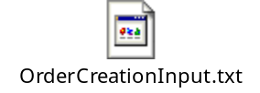

The sample input xml for XPXUpdateCustomerOrderService(new line addition) is:

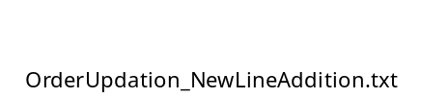

The sample input xml for XPXUpdateCustomerOrderService(line type change) is:

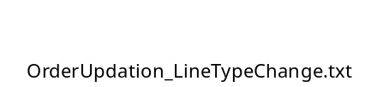

2.3.5 Output Document
<Provide a sample output XML with valid values for each attribute>N/A

2.3.6 Configuration

- XPXChainedOrderCreationService

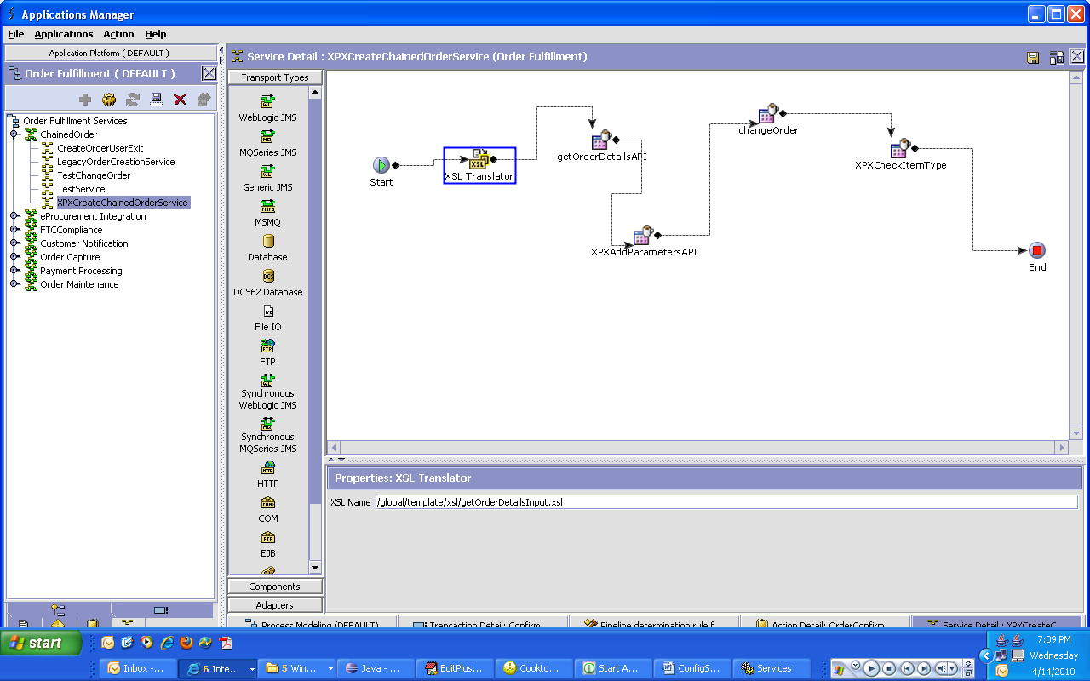

- XPXUpdateCustomerOrderService

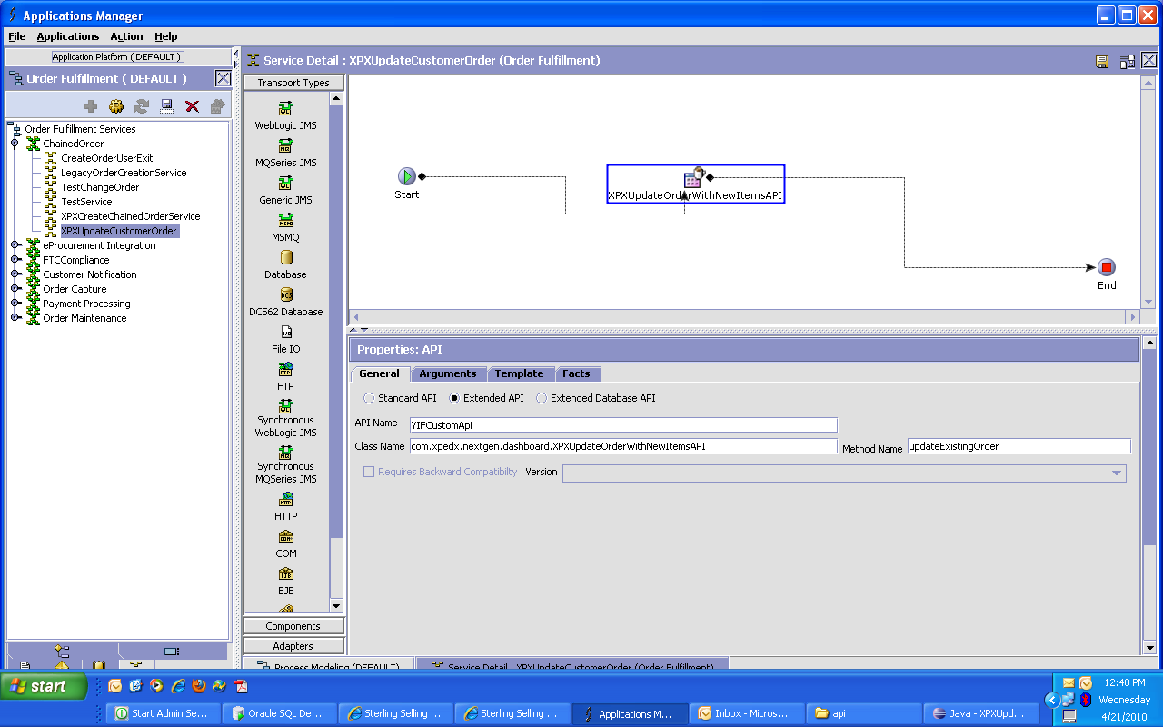

2.3.1.1. <Insert Sub-Component Name>
<Elaborate input and output of each sub-component if applicable>N/A

- Input Document

- Output Document

3. Database Extensions
<Provide the database extensions required for the component in the format provided below. The data types need to be clearly specified. Always Out-of-the-box data types should be reused. If a data type for the given combination doesn’t exist, a new data type name should be specified>
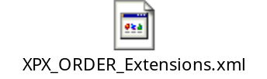

4. Exception and Error Handling
This component will throw an InvalidCategory exception if the category to which the item is to be attached has not been created.
<Provide the list of exceptions (business and system exceptions) the component can throw>

5. Security Aspects
<Provide details on the security aspects of this implementation. Where would these security components reside, what will be encryption that will be used and any audit trails required>N/A

5.1 Ownership
5.2 Encryption
5.3 Audit Trail
5.4 Other Security Aspects

6. Dependencies & Assumptions
<For issues that are dependent on customer: Record all dependencies made for this design including business requirement, performance and technical factors, etc. in JIRA and list the JIRA tickets numbers here

JIRA no | desc | To be validated by  (Team/Person) | Status | Implications if incorrect
1 | Product case enhancement raised for orderedQty increase updation on chained order

<For issues those aren’t dependent on customer: Record all dependencies made for this design including business requirement,performance and technical factors, etc. here

Include only those that are not already documented in SDD If there are changes in SDD, reference the specific dependency and state the revised assumption. New assumption should be approved prior to design review> XReference Section 2.8 – Assumptions in Functional Design Document.

No. | Assumption | To be validated by  (Team/Person) | Status | Implications if incorrect
 | All the elements and its attributes will be available in the change Order input xmls for Order Updation
2 | PersonInfoShipTo and PersonInfoBillTo elements will not be involved in changeOrder for order updation.

7. Unit Test Cases
<Elaborate unit test cases for all the components. Every unit test case should include description, pre-requisites, expected results, etc. The below section should repeat for each component>

7.1 Order Creation(confirmation)

Test No. | Test Description | Execution Instructions | Expected Result
 | Create an order with the items which belongs to THIRD_PARTY,DIRECT_ORDER or STOCK_ORDER. | Submit this order through WebChannel | A Customer order with the selected items to be created. Also, chained orders with the respective item types to get created.
2. | Create an order with the items which does not belong to THIRD_PARTY,DIRECT_ORDER or STOCK_ORDER. | Submit this order through WebChannel | A Customer order with the selected items to be created. Also, chained order of STOCK_ORDER item type to get created.

7.2 Order Updation
Here the test execution should be in the following manner:
- All order creation steps at the start of a scenario is to be done through WebChannel
- The subsequent steps are to be done usng the sample input xmls given in this doc.

Test No. | Test Description |  | Expected Result
 | New Order created with Item third party |  | Customer order with Line type third party created with its corresponding chained order for order type THIRD_PARTY and Customer order line goes to Placed status
 | Add new Items to above Customer order of types DIRECT_ORDER and STOCK_ORDER. |  | Customer order gets appended with new line types of DIRECT_ORDER and STOCK_ORDER and chained orders created for these and the customer lines go to Placed status
 | Add new items of all three types again |  | Customer order gets three more lines and the existing chained orders of the respective types gets the additional line added
2. | New Order created with Item third party |  | Customer order with Line type third party created with its corresponding chained order for order type THIRD_PARTY and Customer order line goes to Placed status
 | Add a line type for two or more number of times of which there is no existing chained order-here its DIRECT_ORDER or STOCK_ORDER |  | The new lines are added to Customer order. A new chained order for the new line type is created and the subsequent lines are appended to this new chained order instead of creating new chained orders
 | Test the scenario 1's second and third steps on this order |  | The new lines to be added to Customer order and also appended to already created chained orders
3. | New Order created with Item Direct Order |  | Customer order with Line type direct order created with its corresponding chained order for order type DIRECT_ORDER and Customer order line goes to Placed status
 | Change line type of above line to STOCK_ORDER |  | The DIRECT_ORDER chained order's orderedQty reduces to zero and goes to Cancelled. As this is the only line as of now, the chained order itself goes to Cancelled. A new chained order gets created with the type STOCK_ORDER. The line type of Customer order should be in Placed status
 | Change line type of above line to THIRD_PARTY |  | The above behaviour is seen on the STOCK_ORDER chained order and a new THIRD_PARTY chained order is created. The Customer order line should be in Placed status.
 | Change above line type to STOCK_ORDER, then THIRD_PARTY and then STOCK_ORDER |  | The above functionality to be observed but the line type change will be transformed as a new line appended to the Cancelled Chained order thereby changing its status to Created. Basically, we should not be creating new chained orders for any of these line types.
4. | New Order created with Item Direct Order & Stock Order & Third Party |  | Customer order gets created with the following line types and chained orders for these get created as well.
 | Change line types for the above lines in the following order: Stock,ThirdParty and then Direct respectively |  | Customer order line types gets changed with the new line types and the existing chained orders are appended with the respective lines making them go to Created status. The Customer order lines should be in Placed status.
 | Change line types for the above lines in the following order: Direct,Stock and then ThirdParty respectively |  | Customer order line types gets changed with the new line types and the existing chained orders are appended with the respective lines making them go to Created status. The Customer order lines should be in Placed status.
5. | New Order created with Item of THIRD_PARTY. Add a new line DIRECT_ORDER and also change the line type of the THIRD_PARTY to STOCK_ORDER |  | New Chained orders of DIRECT_ORDER and STOCK_ORDER to be formed and also the THIRD_PARTY CHAINED line to be cancelled.
 | Add new lines of THIRD_PARTY and DIRECT_ORDER and change the line type of STOCK_ORDER to DIRECT_ORDER |  | New lines added to Customer order and also appended to existing chained orders of the respective type. Also STOCK_ORDER changed to DIRECT_ORDER on Customer order and line on STOCK_ORDER chained order goes to Cancelled
6. | Create an order from WebChannel such that the PAYMENT_APPROVAL hold is set/create an order such that the Rules Engine sets the NEEDS_ATTENTION hold on the Customer order |  | No chained orders should be created
7. | Create an order through WebChannel such that WillCallFlag is set as “P” in the customer Order whose profile has no orderUpdateFlag set as “N” |  | Check /Order/Extn/@ExtnWebHoldFlag and /Order/Extn/@WebHoldReason. The former should have value “Y” and the latter should have value “Will Call Requested”
8. | Create an order through WebChannel such that WillCallFlag is not set as “P” in the customer Order whose profile has orderUpdateFlag set as “N” |  | Check /Order/Extn/@ExtnWebHoldFlag and /Order/Extn/@WebHoldReason. The former should have value “N” and the latter should have value “New Customer Setup”
9. | Create an order through WebChannel such that WillCallFlag is set as “P” in the customer Order whose profile has orderUpdateFlag set as “N” |  | Check /Order/Extn/@ExtnWebHoldFlag and /Order/Extn/@WebHoldReason. The former should have value “N” and the latter should have value “Will Call Requested & New Customer Setup”
10. | Create an order through WebChannel for a customer whose customer profile has the orderUpdate flag set as “N” |  | After creation of the chained orders, there should be an alert raised on the Customer order in the DEFAULT queue.(Check if the console user has subscribed to the DEFAULT queue if it is to be viewed by the user).

